**CS 408 - Group 3**

**Project 07 - Support Vector Machine (SVM)**

**Group Members**

S/18/427 - Janith Kulatunga

S/18/030 - Supul Edirisinghe

S/18/562 - Sanjana Wijenayaka

S/18/335 - Sachini Dasa

S/18/557 - Nilmi Wickramasinghe

**01.Introduction**

1.1 SVM(Support Vector Machine)

SVM has been first introduced in the paper of Support Vector Networks[1]. This paper is foundational in the field of machine learning and presents the theoretical underpinnings of SVM, a powerful supervised learning model widely used for classification and regression tasks.

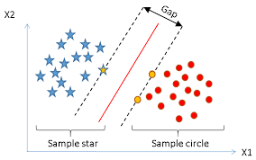

**Figure 1.1** : *Linear SVM*

1.1.1 Applications of SVM

**Image classification**

SVMs can be used to identify objects or categories within images. For example, an SVM could be trained to distinguish between images of cats and dogs.

**Text classification**

SVMs can be used to categorize text documents into different topics or sentiments.For instance, an SVM could be trained to classify email messages as spam or not spam.

**Bioinformatics**

SVMs can be used to predict protein structures or gene functions. For example, an SVM could be trained to predict whether a protein is a membrane protein or a soluble protein.

**Handwriting recognition**

SVMs can be used to recognize handwritten characters or digits.For instance, an SVM could be trained to recognize handwritten digits from 0 to 9.

1.2 Kernel Types

Mainly in the terms of kernel there are many kernel types in use to map the non - linear datasets into higher dimension such as Linear,Polynomial,Exponential and Gaussian.

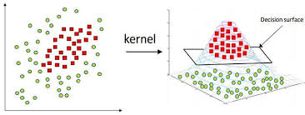

**Figure 2.2** : *Higher Dimensional kernel*

1.2.1. Linear Kernel

The linear kernel is the simplest kernel function used in Support Vector Machines (SVMs) and other kernelized algorithms. It is defined as

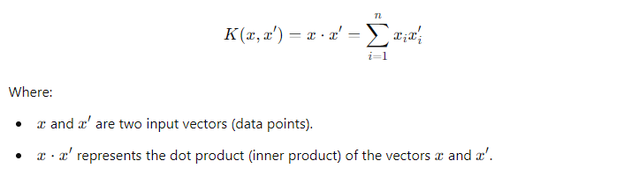

The linear kernel is commonly used in text classification tasks where the number of features (e.g., words) is very large. It is particularly effective for datasets with a large number of features and is preferred when the relationship between features and labels is roughly linear.

1.2.2.Polynomial Kernel

The polynomial kernel is a non-linear kernel function that represents the similarity of vectors in a feature space over polynomials of the original variables. It is defined as

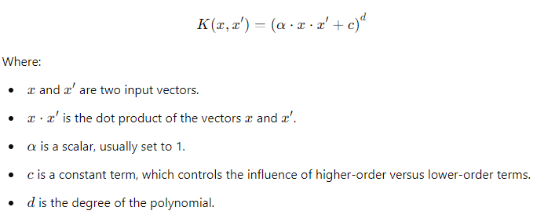

The polynomial kernel is useful when the data is not linearly separable, but the relationship between the features can be captured by a polynomial of a certain degree. It allows for more complex decision boundaries compared to the linear kernel, making it suitable for datasets with more complex patterns.d controls the flexibility of the decision boundary. A higher degree makes the model more complex.C adjusts the impact of higher-degree terms versus lower-degree ones. A larger ccc reduces the influence of higher-degree terms

1.2.3 Gaussian Kernel

The Radial Basis Function (RBF) kernel, also known as the Gaussian kernel, is a popular kernel function used in various machine learning algorithms, particularly in Support Vector Machines (SVMs).

The RBF kernel is defined as:

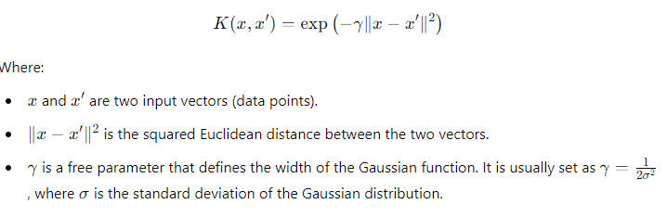

In SVMs, the RBF kernel is particularly favored because it can handle complex, non-linear relationships without requiring a prior transformation of the data. It implicitly maps the input space into an infinite-dimensional feature space, allowing the SVM to find the optimal hyperplane for classification.A smaller gamma value makes the decision boundary smoother (less complex).

**02.Data set Analysis**

As For the dataset we are going use is Vehicle Image classification dataset in Kaggle <https://www.kaggle.com/datasets/nelyg8002000/commercial-aircraft-dataset?select=1_Liner+TF>

which contain more than 5,000 images distributed on seven categories as Planes and another kaggle dataset for cars <https://www.kaggle.com/datasets/jessicali9530/stanford-cars-dataset> .As for our data set we are going to use Cars and plane image data folders to check how the SVM works on the classification with different functions on the different kernel types such as linear, polynomial,Exponential, Gaussian and

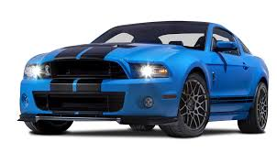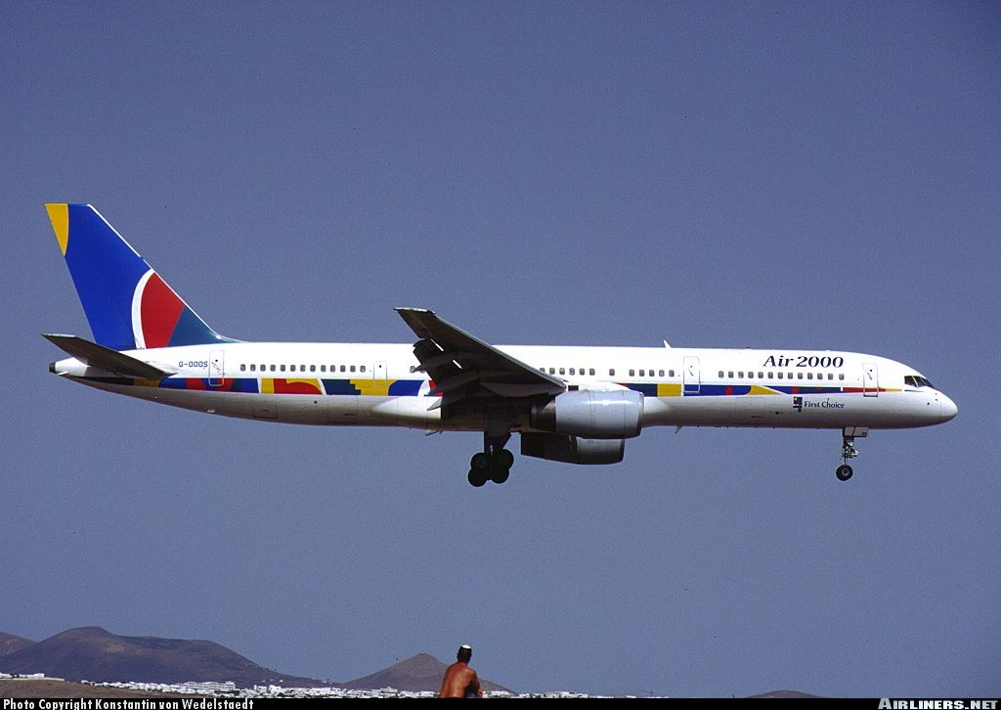

**Figure 2.1** : *Dataset cars and planes images*

When we analyze the class Distribution we can see that the classification can be done with the Cars and planes having 1000 images under each label so we used that amount of images from each class.

If we categorize by the classes and get the color histograms for each classes we can clearly see there is no major difference in the distribution and Cars class have the major intensity difference.

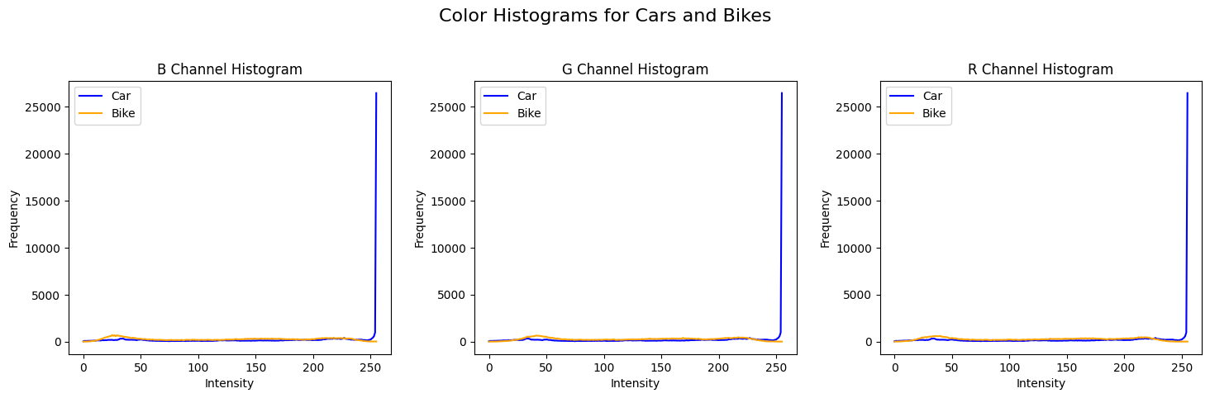

**Figure 2.5** : *Color histogram by classes*

To apply the edge distribution on the images we have taken the figure below(Figure 2.5)

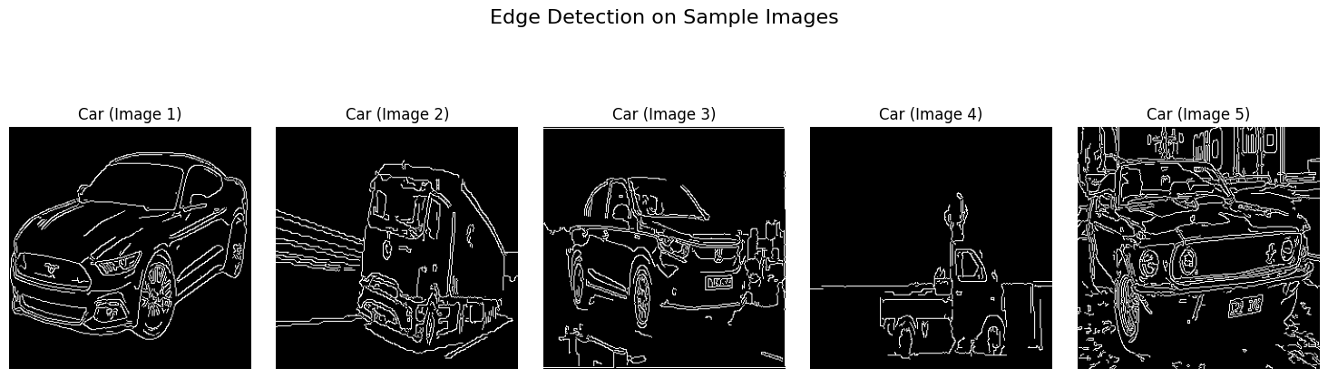

**Figure 2.5** : *Distribution of Edges in the car dataset*

From getting summary statistics we can see that the mean ,median and s.d of the pixel values which will be use to identify with SVM and give outputs

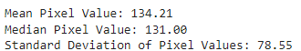

With this data analysis we can see that the dataset seems relatively balanced between Cars and Planes, which is good for training a classifier.Most images have a similar width and height, suggesting consistency in the dataset. This can simplify preprocessing steps as the dataset might not need extensive resizing.The color histograms show the distribution of color intensities for each channel (Red, Green, Blue) within each class. This can highlight potential color-based features that distinguish Cars from Planes. For example, if Cars tend to have a higher concentration of red pixels compared to planes, this could be a useful feature for classification.

The mean, median, and standard deviation of pixel values provide a general understanding of the pixel intensity distribution across the dataset. This can be useful for normalization or identifying outliers.Feature engineering can be done with edge-based features (like HOG descriptors) for training classifiers.

**03.Methodology**

**1. Import Required Libraries**

Libraries such as numpy, pandas, scikit-learn, and opencv (or PIL for image handling). For SVM, scikit-learn is particularly useful as it provides an implementation of the SVM algorithm.

**2. Load the Images and Convert It to a DataFrame**

Loading Images: Use OpenCV to read the image. Convert the image into a flat array where each pixel's RGB values become features.

Flattening: Images are typically 2D arrays with RGB channels. Convert them into a 1D array for each image.DataFrame Creation: Construct a DataFrame with each image's features as rows and labels as columns.

**3. Separate Input Features and Targets**

Features (X): The pixel values or extracted features from images.

Targets (y): The labels or categories for each image.

**4. Split Train and Test Data**

Splitting: Use train_test_split from scikit-learn to divide the dataset into training and testing sets. This helps evaluate how well the model performs on unseen data.

**5.Build and Train the Mode**l

When classifying an image dataset with over 1000 images into 2 classes using Support Vector Machines (SVM), the selection of parameters is crucial for achieving optimal performance. Here’s a guide on choosing and tuning the best parameters for SVM:.

Key Parameters for SVM

C (Regularization Parameter)

Controls the trade-off between achieving a low training error and a low testing error. A high C value aims to minimize training error, while a low C value focuses on achieving a larger margin, potentially leading to more misclassification on the training set.

Typical Values such as 0.1, 1, 10, 100, and 1000.

gamma (Kernel Coefficient)

For the RBF(radial bias function) and polynomial kernels, gamma defines the influence of a single training example. A high gamma value makes the decision boundary more flexible and can lead to overfitting, while a low gamma value makes the decision boundary more rigid.

Typical Values such as 0.0001, 0.001, 0.01, 0.1, 1, and 10.

kernel (Kernel Type)

Defines the type of decision boundary.

Common choices are:

linear: Useful if the data is linearly separable.

rbf: Radial basis function kernel, often a good default for non-linear data.

poly: Polynomial kernel, which can capture more complex relationships.

sigmoid: Less commonly used but can be considered for specific cases.

Typical Values: linear, rbf, poly.

**6. Model Evaluation**

Prediction: Use the trained model to predict the labels of the test set.

Accuracy Score: Evaluate the model's performance using accuracy or other metrics like precision, recall, and F1 score.

**04.Implementation**

Import required libraries

Data preparation

Getting images from the directory and splitting the dataset to Train, validate, test categories

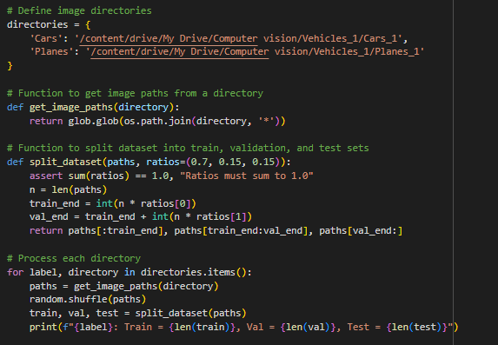

Load the Images and Convert It to a DataFrame

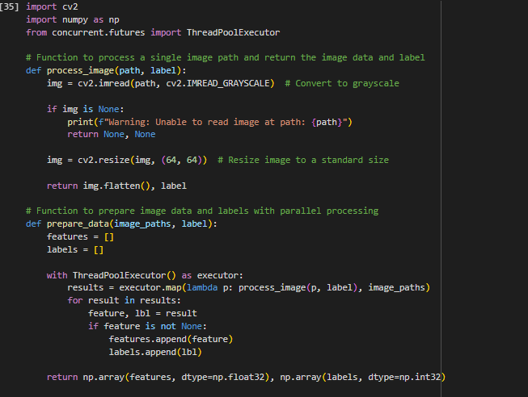

Build and Train the Model

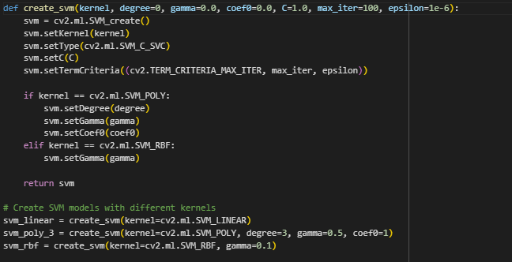

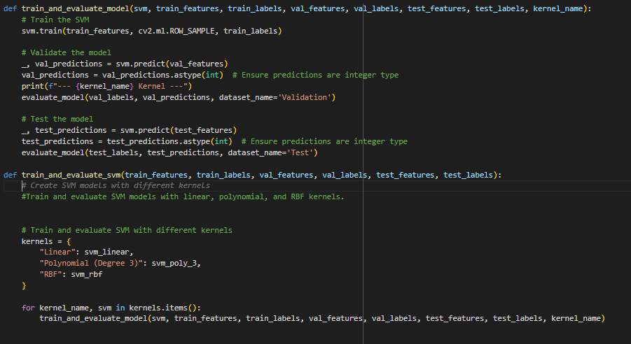

Model evaluation

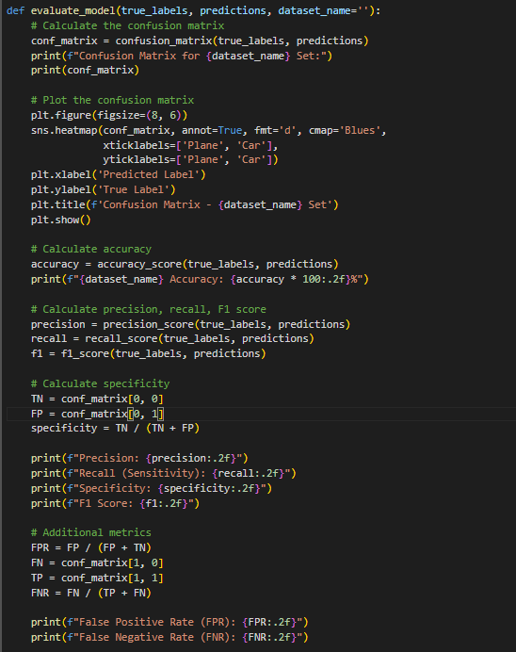

**05.Results**

Linear Model

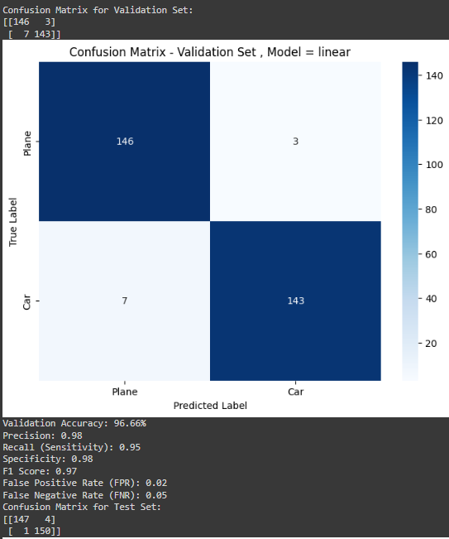

**Figure 5.1** : *Model 1 which used Linear kernel*

Poly model

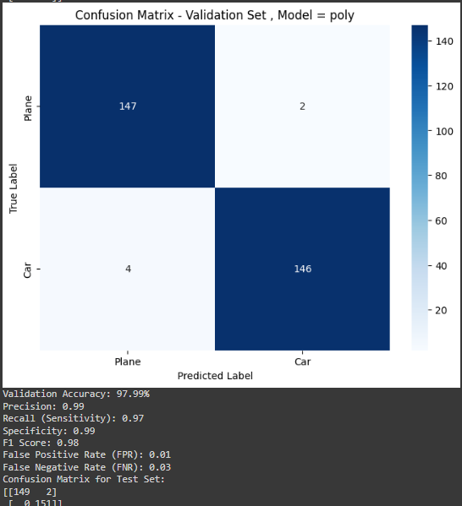

**Figure 5.2** : *Model 2 which used polynomial kernel*

Rbf model

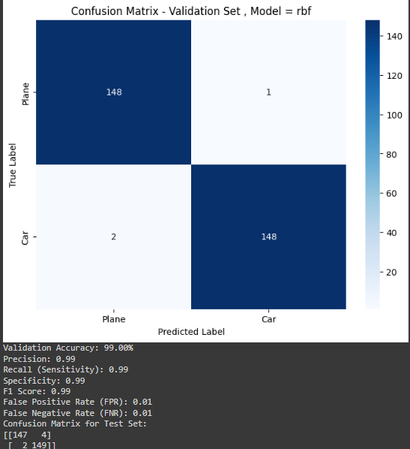

**Figure 5.3** : *Model 3 which used gaussian(rbf) kernel*

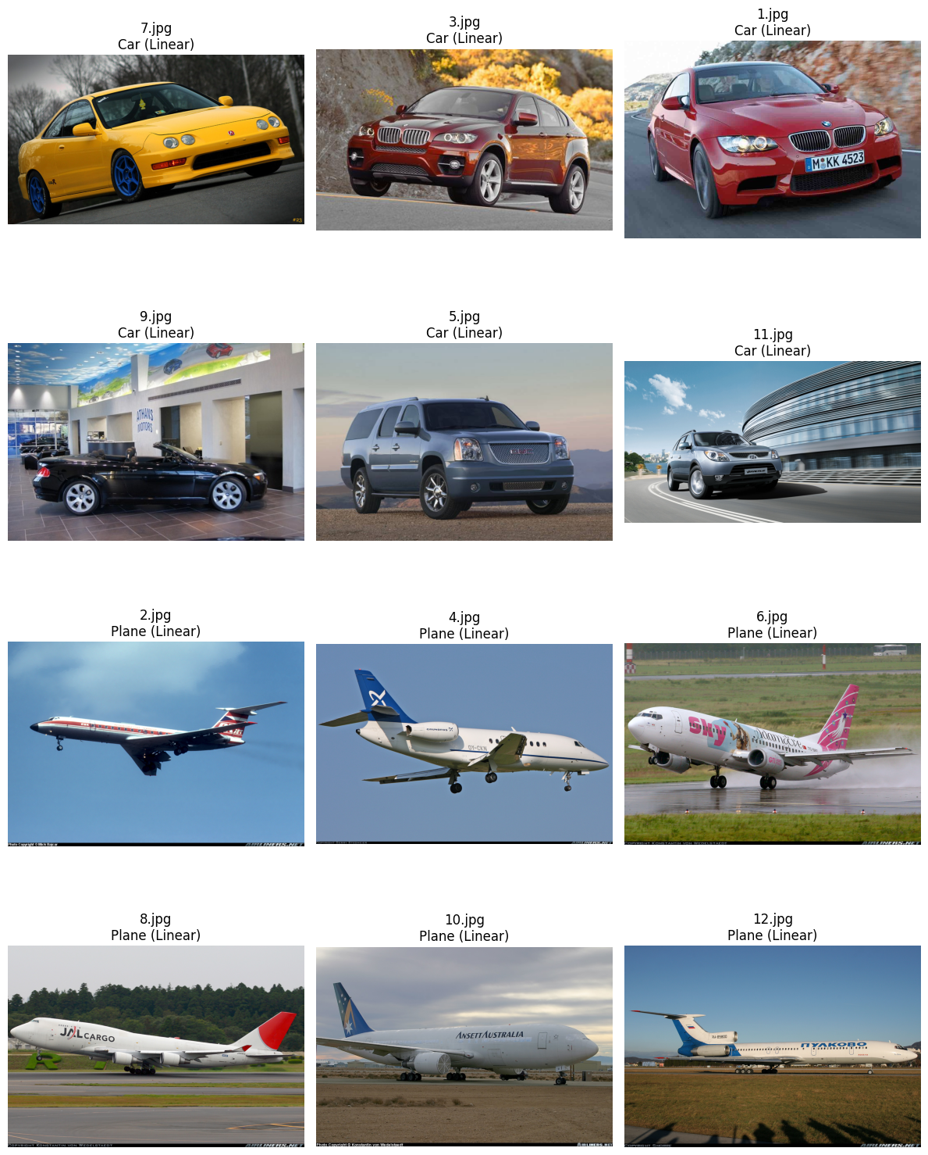

**Figure 5.4** : Test *Results obtained with linear model*

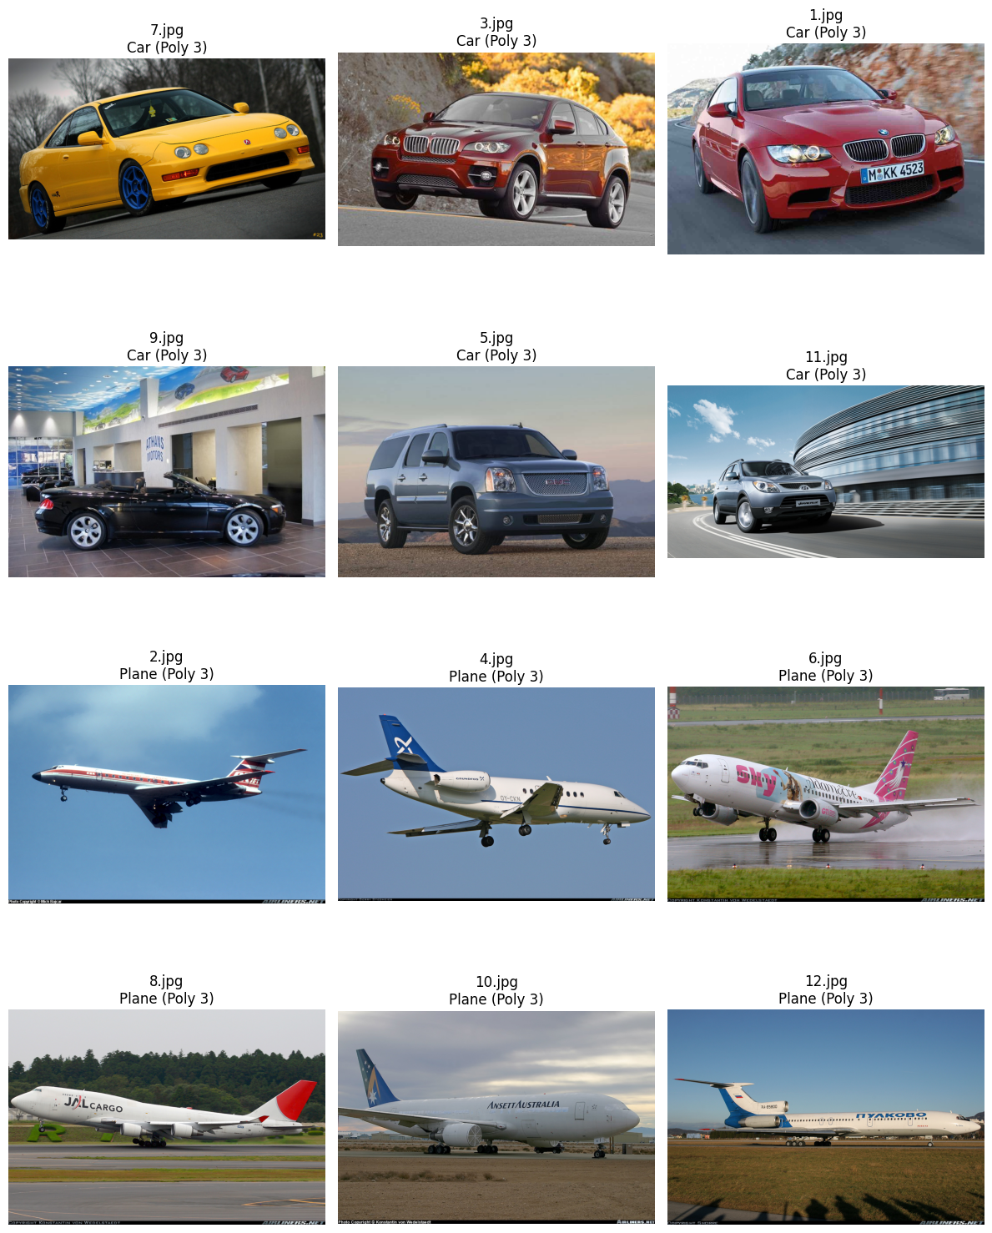

**Figure 5.5** : Test *Result obtained with polynomial model*

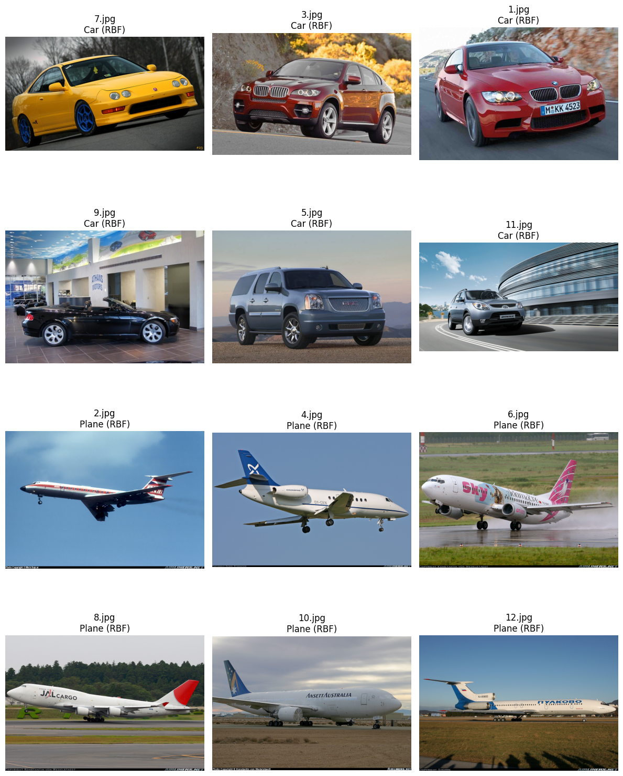

**Figure 5.6** : *Test Result obtained with rbf mode*

**06.Discussion**

**Type of Kernel used**

The performance of the SVM models in this project varied depending on the type of kernel we used.

1. Linear Kernel Performance

This effectively classifies the images when the data is approximately linearly separable. In our datasets, its performance was limited compared to the other kernels used , by the complexity of the dataset.

1. Polynomial Kernel Performance

This introduces a non-linear decision boundary which allows the model to capture more complex relationships between the features. By adjusting the degree of the polynomial, we were able to control the flexibility of the model. The results we obtained indicate that the Polynomial kernel performed better than the linear kernel for the dataset of cars and planes. However, the increased complexity also introduced the risk of overfitting, particularly for higher-degree polynomials, which required careful tuning of the model parameters

1. RBF Kernel Performance

The RBF kernel performed significant improvement(validation accuracy-99%, precision-0.99, recall-0.99, F1 score-0.99) in classification performance compared to the previous kernels. However, selecting the appropriate gamma parameter was crucial, as a high gamma value could lead to overfitting, while a low value might underfit the data. In our experiments, the RBF kernel achieved the best balance between bias and variance, leading to higher accuracy.

**Model Evaluation**

The SVM model with the RBF kernel achieved an accuracy of 99% in classifying images of cars and planes. The F1-score was also high, at 0.99, indicating excellent overall performance. This suggests that the model is effective in distinguishing between cars and planes with minimal errors.

**07.Conclusion**

In this project, we explored the use of Support Vector Machines (SVM) for classifying images of vehicles, specifically cars and planes, using a dataset from Kaggle. Our approach involved several key steps, including dataset analysis, feature extraction, model training, and evaluation.

Through the analysis, we observed that the dataset was relatively balanced and consistent, making it suitable for SVM classification. We applied different kernel functions—linear, polynomial, and Gaussian (RBF)—to assess their performance in separating the vehicle classes.The results demonstrated that while linear kernels are effective for linearly separable data, non-linear kernels like polynomial and Gaussian were better suited for the more complex patterns present in our image data.So we can conclude that the best result can be obtained by using Gaussian(RBF) kernel in the case of complex image data set.

Our findings suggest that the selection of the kernel type, along with appropriate parameter tuning, significantly impacts the performance of the SVM model. By experimenting with different values for the regularization parameter (C) and kernel coefficient (gamma), we were able to optimize the SVM model for better accuracy and generalization.

Overall, this project highlighted the versatility and power of SVMs in image classification tasks. The methodology and results presented here provide a strong foundation for future work in applying SVMs to other complex datasets, with potential improvements in feature engineering and kernel optimization to further enhance classification performance.

**08.References**

[1] C. Cortes and V. Vapnik**,** "Support-Vector Networks," *Machine Learning,* vol. 20, no. 3, pp. 273-297, 1995, doi: 10.1007/BF00994018.

[2] “OpenCV: Introduction to support Vector machines.” https://docs.opencv.org/4.x/d1/d73/tutorial_introduction_to_svm.html

[3] Rajeev, “SVM (Support Vector Machine) for classification,” May 21, 2022. https://www.kaggle.com/code/rajeev102001/svm-support-vector-machine-for-classification

[4]https://www.geeksforgeeks.org/image-classification-using-support-vector-machine-svm-in-python/